Deploying WordPress application using docker-compose

Step-1 Launch an EC2 instance with instance type t2.micro and image amazon Linux.

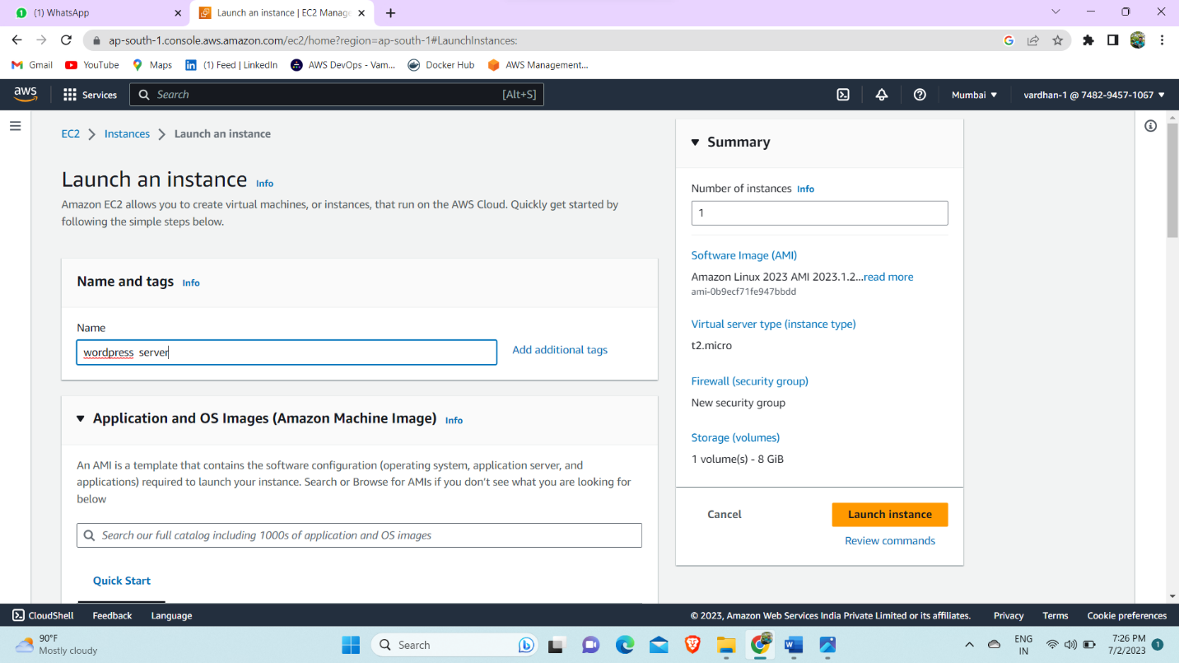

Step-2 Now connect to that instance through SSH key.

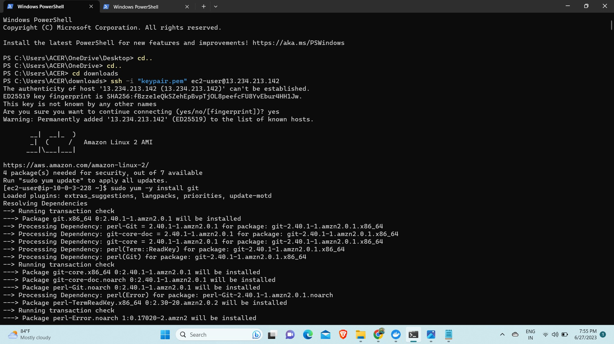

Step-3 Now install git by using command Sudo yum –y install git.



Step-4 Now install docker ,enable docker and start docker by using commands – sudo yum –y install docker, sudo systemctl enable docker and sudo systemctl start docker.

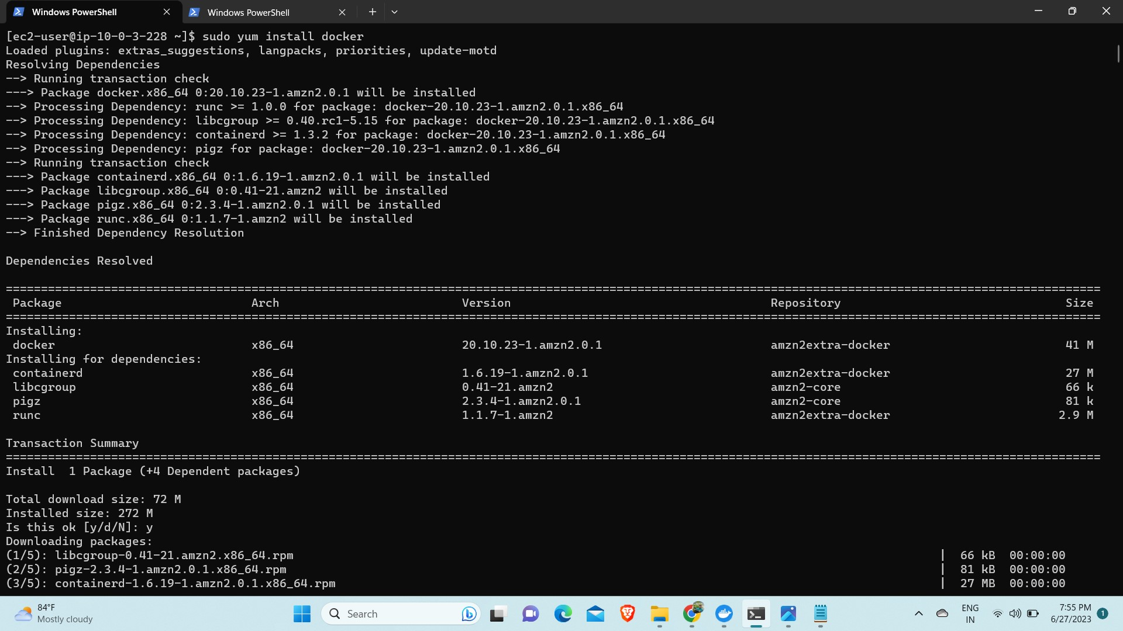

Step-5 Now install docker-compose using command ---sudo curl -L "https://github.com/docker/compose/releases/latest/download/docker-compose-$(uname -s)-$(uname -m)" -o /usr/local/bin/docker-compose

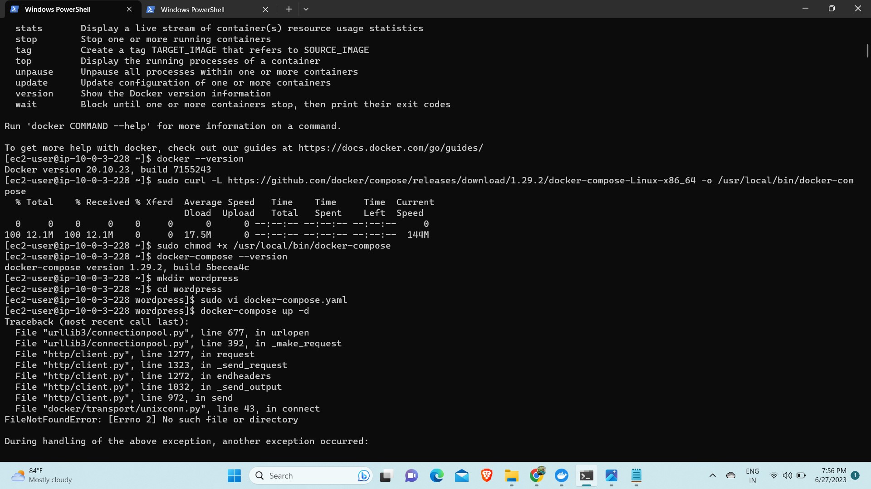

Step-6 Now give execute permissions to docker-compose and check the version using docker-compose –version to make sure docker-compose is installed.

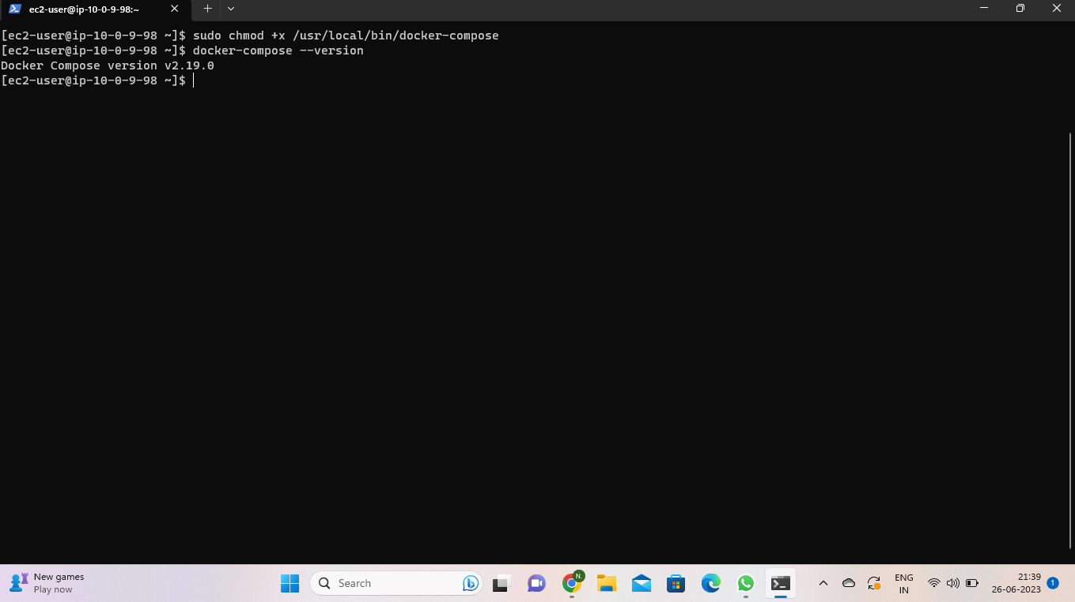

Step-7 Now create a docker-compose.yml file and write a yml script for database and WordPress.

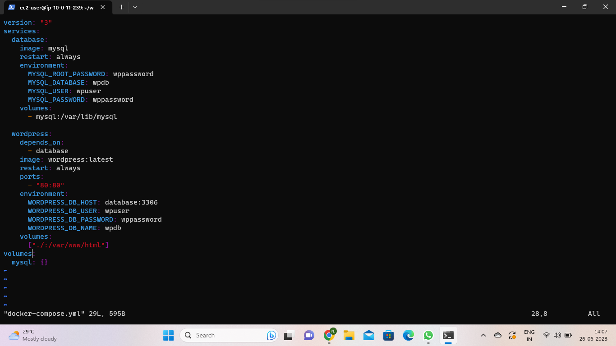

Step-8 Now restart docker again and run it by using the command docker-compose up –d.

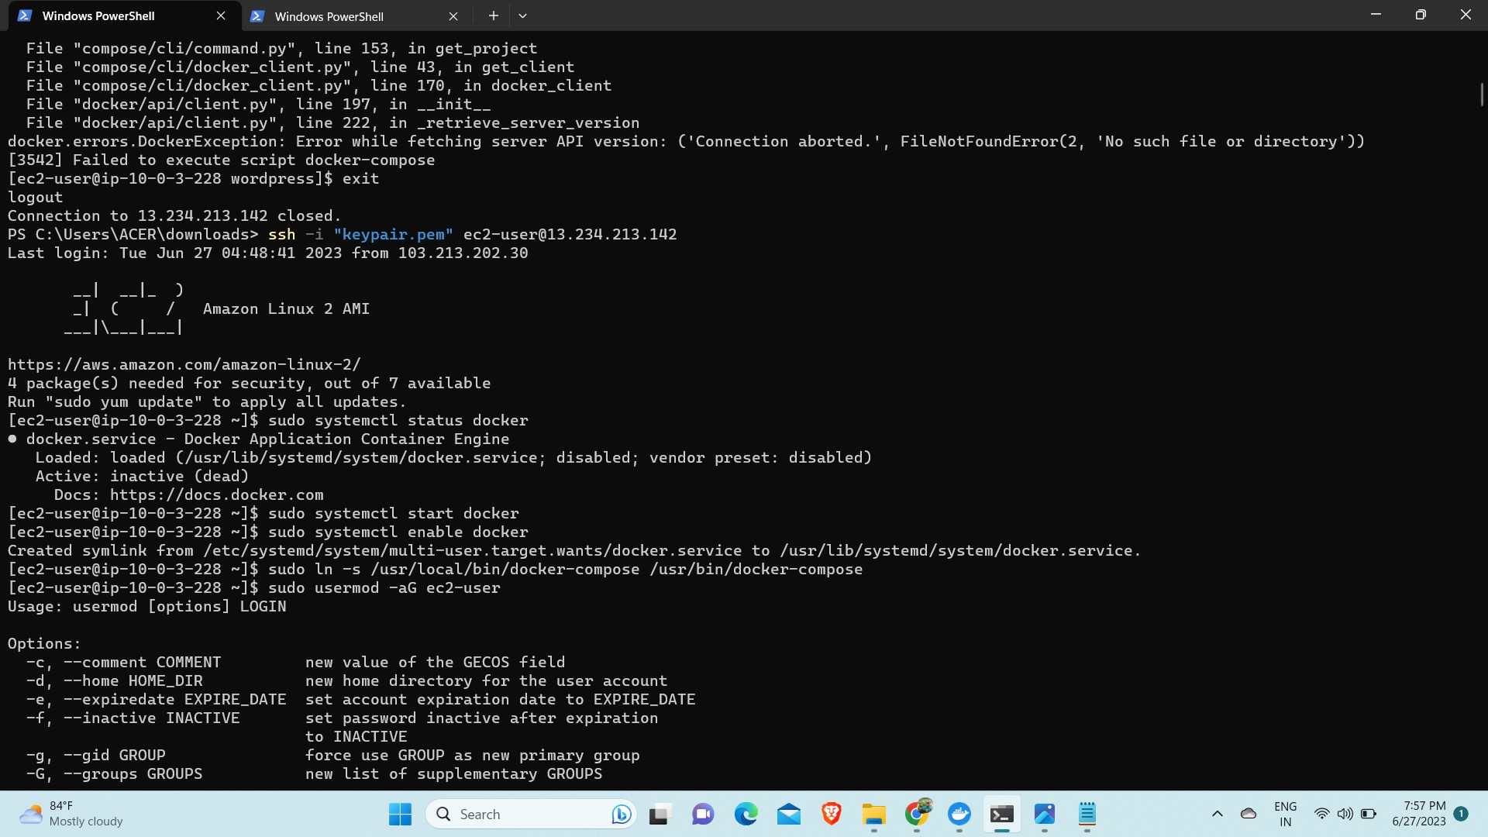

Step-9 Check if the containers are created or not by using the command Docker ps.

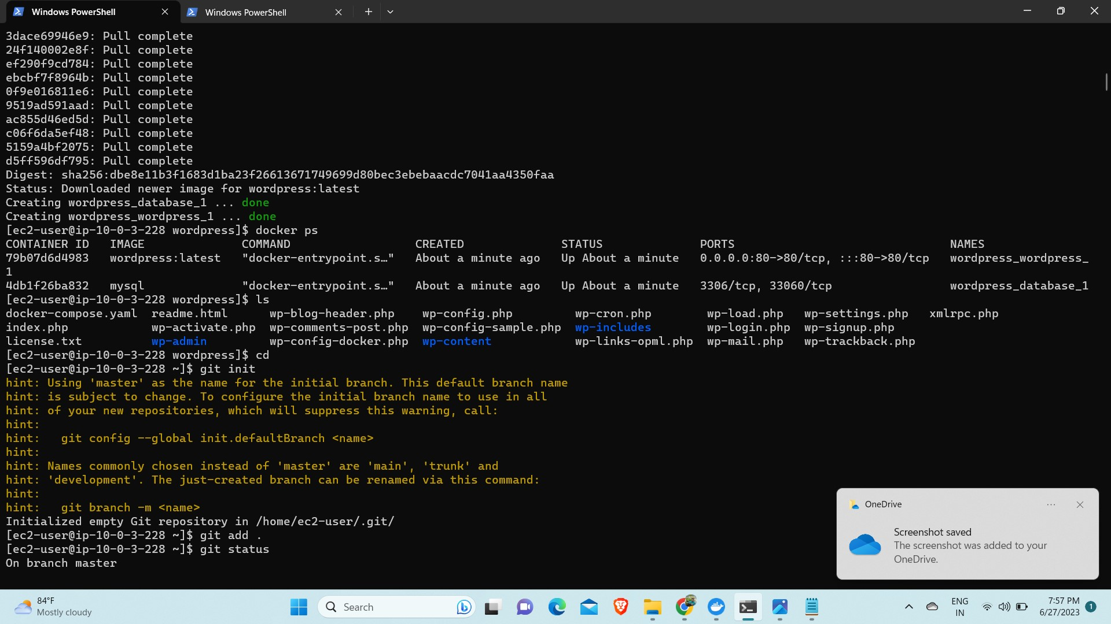

Step-10 Now browse the public Ip of instance and you will the WordPress webpage.

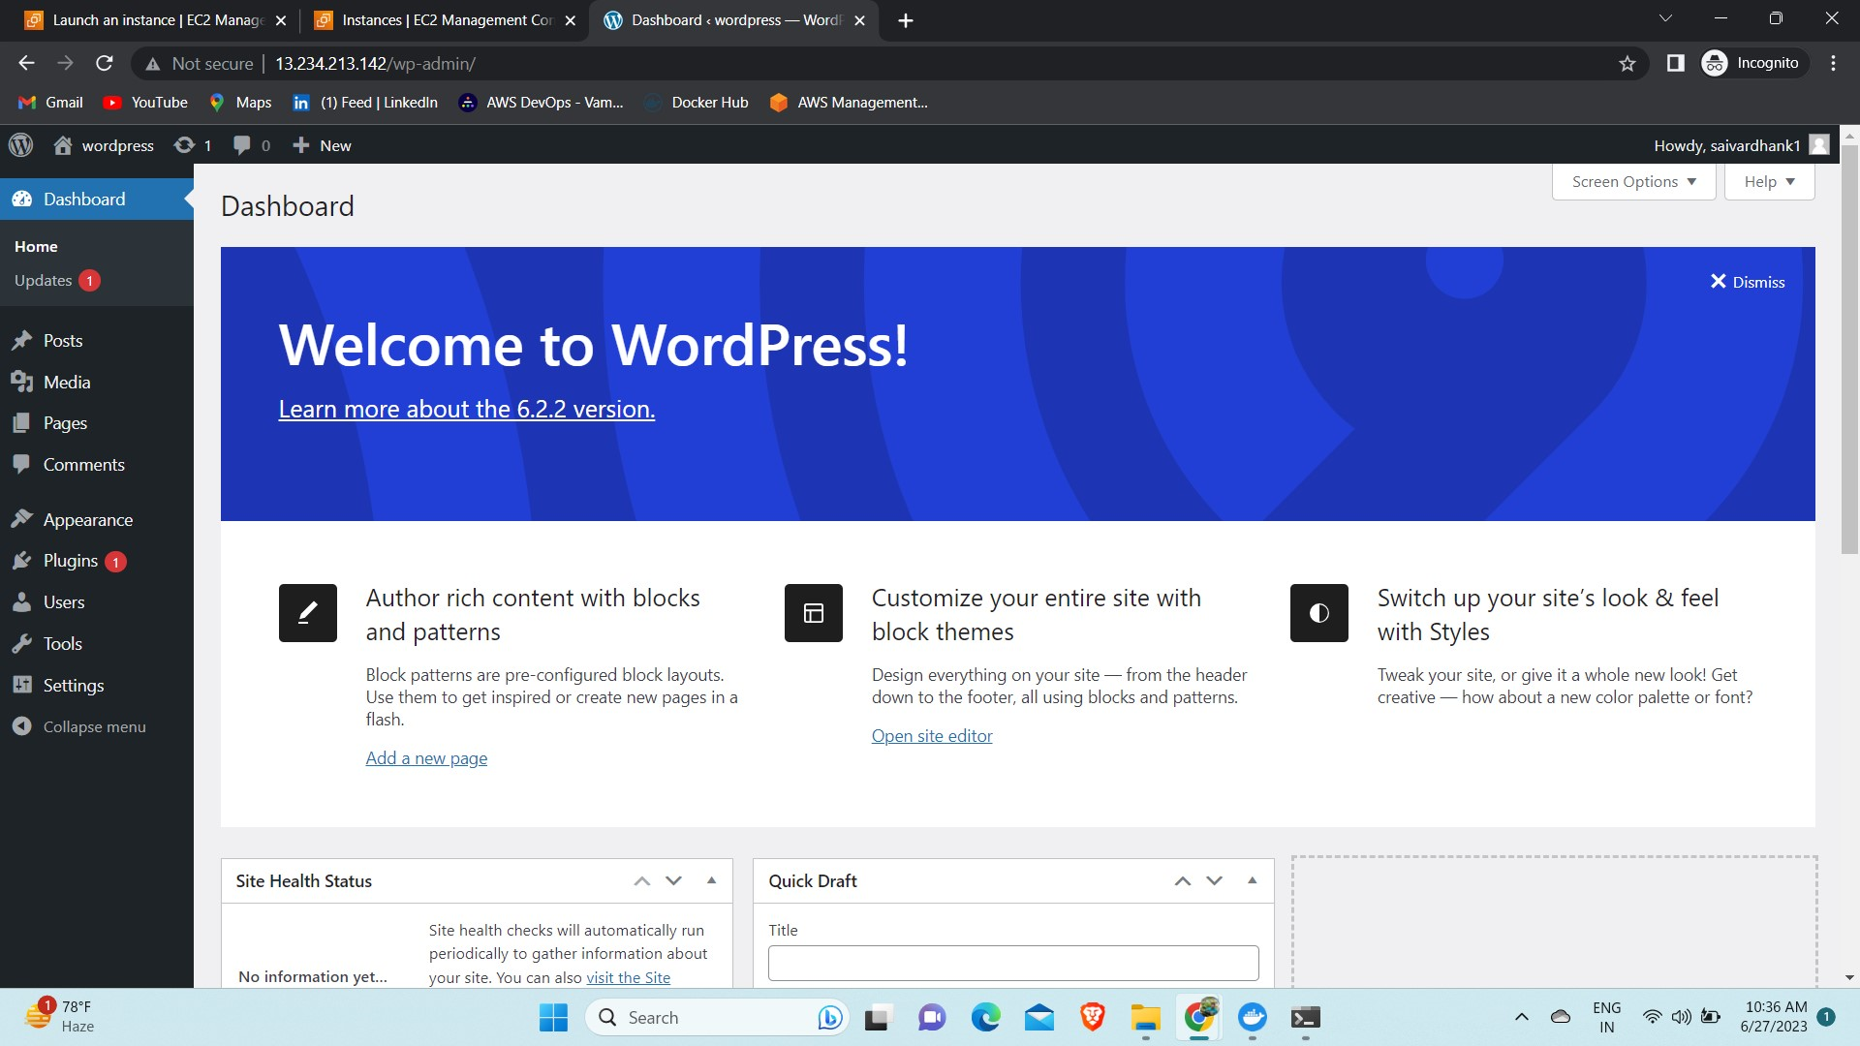

Step-11 Now push all your files to the GitHub private repository. So that even if you delete the files in your local system it will not get deleted in your GitHub repository. 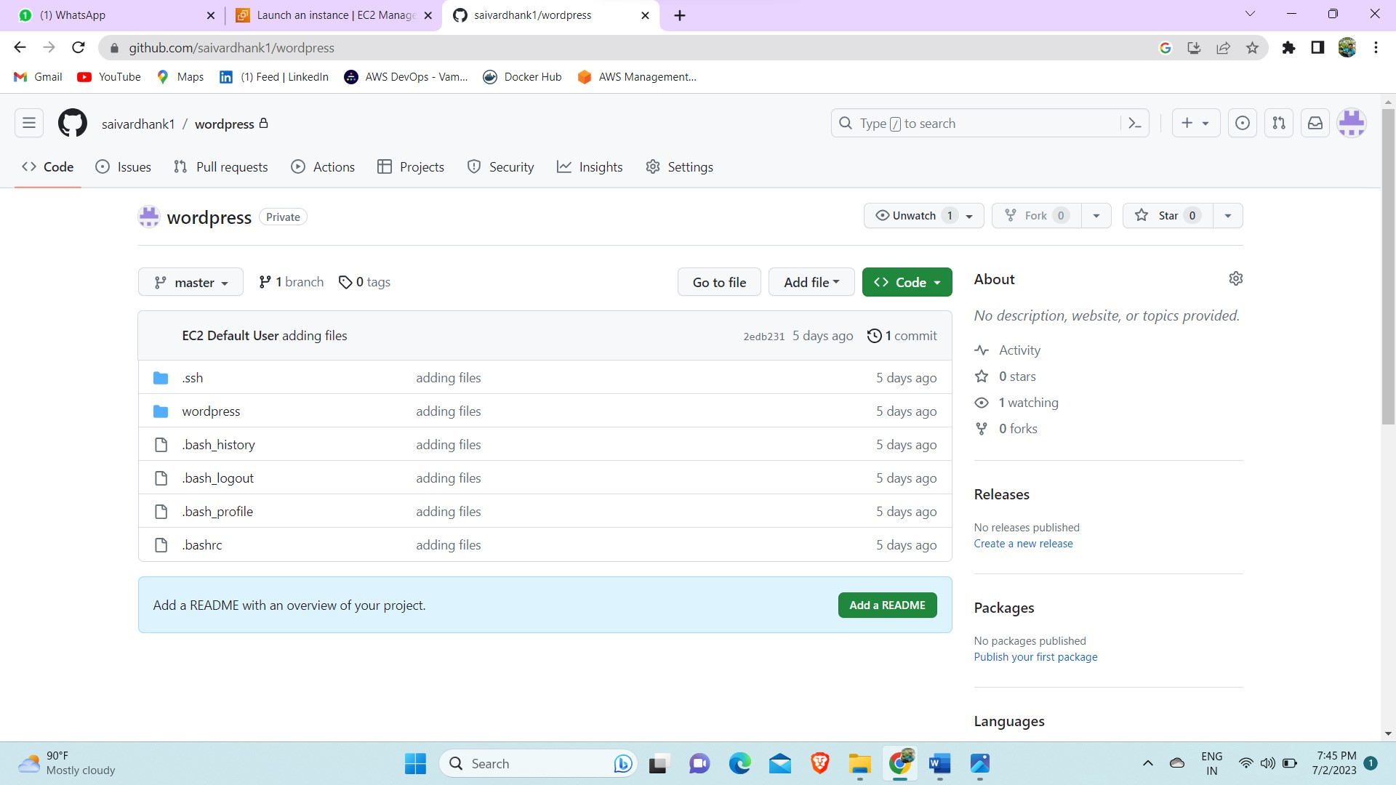

\* Now as we have done all the work manually, we use Jenkins to automate all these tasks manually.

Step-12 Login to your AWS console and create an EC2 instance with an amazon Linux machine and instance type t2.medium.

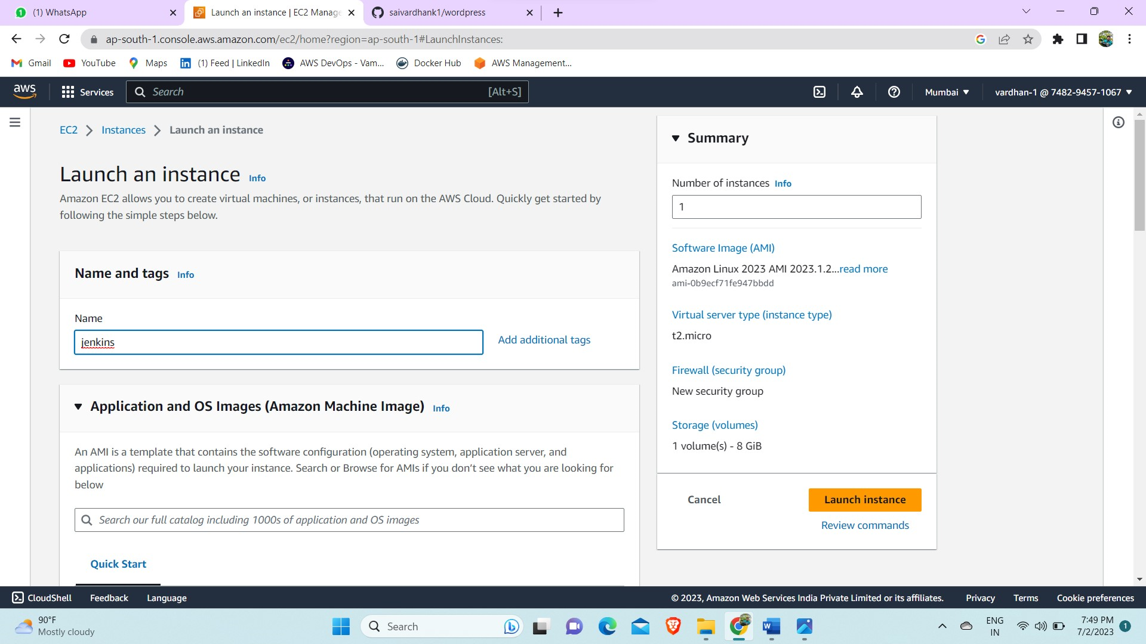

Step-13 Now install Jenkins in the instance by using following commands.

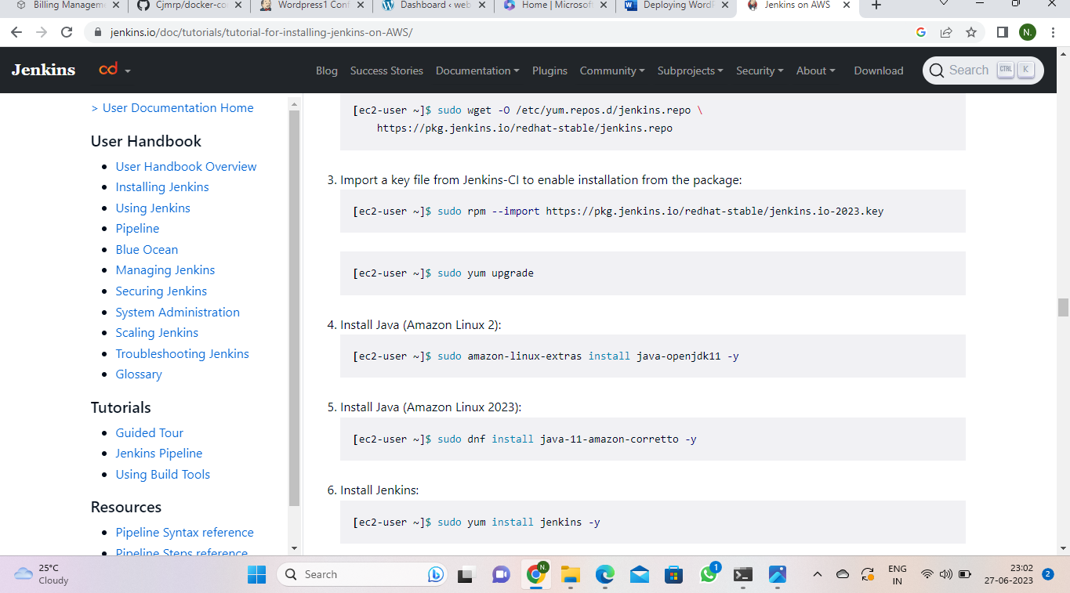

Step-14 Now browse the public ip of the instance with port 8080 Jenkins will open then configure the details. Login into the Jenkins server and create a new freestyle project.

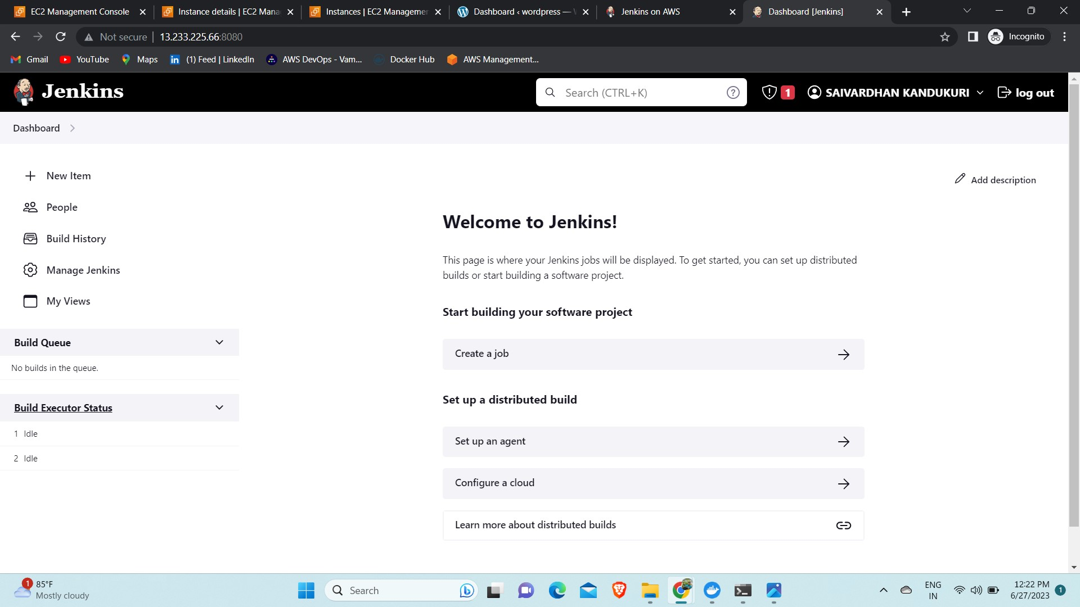

Step-15 Now in source code management select git and add the repository in which the files are present. And go to build in steps and select execute shell and write the commands and save.

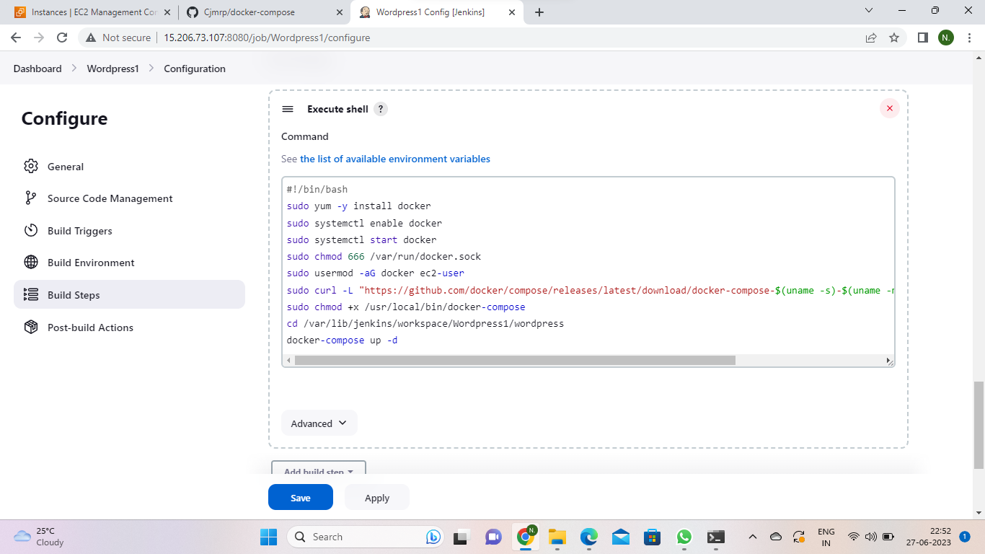

Step-16 Now browse the public Ip of the instance with port 80.

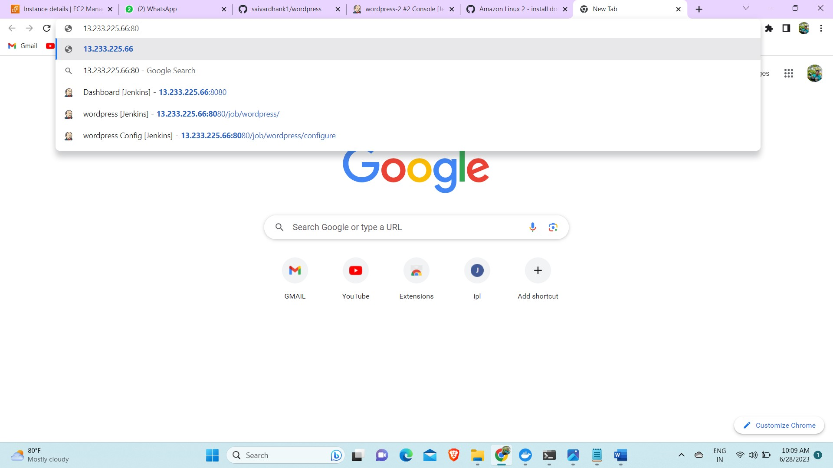

Step-17 You can see the WordPress web page and this is the final output.

